# WAA Bat Specifications

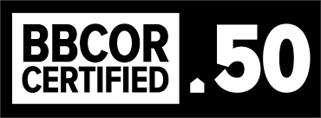

**Fall Baseball 1st-8th Grade: USA**

Bats up to 2 5/8” diameter “stamped” USA Baseball of any drop weight are permitted.

Non-USA stamped bats up to 2 ¼” in diameter are permitted.

**NO USSSA stamped bats are allowed**.

All wood bats are permitted.

All other bats not meeting the above descriptions are prohibited.

# Fall Baseball High School: BBCOR

Bats up to 2 5/8” diameter and no longer than 36 inches in length that are “stamped” BBCOR

.50.

Bats cannot weigh, numerically, more than three ounces less than the length of the bat (e.g. a 33- inch-long bat cannot be less than 30 ounces).

All wood bats are permitted.

All other bats not meeting the above descriptions are prohibited.